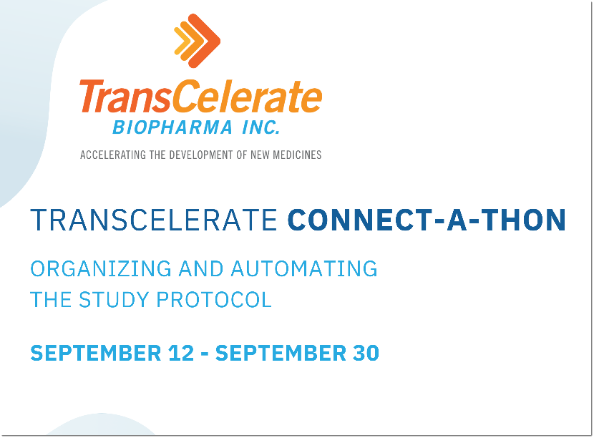

**Participant Check List**

1. [Register](https://transcelerate.github.io/ddf-home/CaT_home.html) your full team for the Connectathon before the event starts on September 12th
2. Confirm you can access the SDR demo environment if you plan on using it for the event, this will include receiving your individual access and your organizations authentication certificate.
3. Review the **Connectathon Project Categories** below and plan which categories you will be submitting project submission under.
4. Review **Participant Key Dates / Resources** below and attend or review the various participant information sessions.
5. Visit the main DDF Github page and DDF Homepage to become more familiar with the core concepts of DDF.
6. Attend Connectathon Kick Off Call to start the event.

**Connectathon Project Categories**

* **Data Interoperability**: Of the complete set of data elements within the USDM, how many elements are you able to store and transfer (up and/or down)
* **User Interface/Experience**: Demonstrates solution features around displaying relevant data in an easy to use and understand format
* **Analytics/Reporting**: Demonstrates solution features focused on performing background analysis of relevant DDF data
* **Supplemental Data and Standards**: Demonstrates solution features dedicated to layering additional data or incorporating additional standards in addition to what is described with the USDM
* **Process Automation**: Demonstrates solution features related to workflow and process automations, both for input and output of the solution
* **SDR Host Migration**: Proven ability to migrate, deploy, validate, and successfully connect to a hosted SDR instance on a novel system architecture

**Connectathon Participant Key Dates / Resources**

|  |  |  |
| --- | --- | --- |
| Date | Item(s) | Link(s) |
| On Demand | DDF General Background videos  DDF Connection Showcase videos  USDM / SDR Revision 0.5 documentation | [Video](https://www.youtube.com/watch?v=082onW7jhe4)  Recording [1](https://www.youtube.com/watch?v=R98PfI0iXqA), [2](https://www.youtube.com/watch?v=EjBCok4HyNM), [3](https://www.youtube.com/watch?v=4RQHx2GMm3k)  [Document](https://github.com/transcelerate/ddf-home/blob/main/documents/DDF_R0.5_Release_Documentation.docx) |
| 08/25/22 11:00 AM EST | Open Q&A Session | [Recording](https://www.youtube.com/watch?v=C7gLc4JtmPg) |
| 09/06/22 11:00 AM EST | Sample Data Review / Q&A | Recording TBD |
| 09/12/22 11:00 AM EST | Connectathon Kick Off Call | Recording TBD |
| 09/30/22 11:00 AM EST | Connectathon Closing Call | Recording TBD |